**HCX Flight Computer – Field Manual**

**Preface**

The purpose of this manual is to give an unfamiliar user a competent understanding of the HCX flight computer and its uses. This manual contains a pre-flight check list, post-flight check list, necessary operation procedures and technical specifications. This manual was written with safety in mind, and all instructions should be followed exactly to ensure the most effective and safe use of the HCX flight computer.

**Table of Contents**

1. Operation Overview (Basics) ………………………………… 1
2. Pre-Flight Set-Up …………………………………………….. 3
3. Pre-Flight Checklist ………………………………………….. 6
4. Post-Flight Checklist …………………………………………. 7

**Operation Overview**

In this section, the basic parts, processes and features of the HCX flight computer will be introduced. The information in this section is necessary for effective operation of the HCX flight computer and should be read first, before any operation is attempted.

**The HCX**

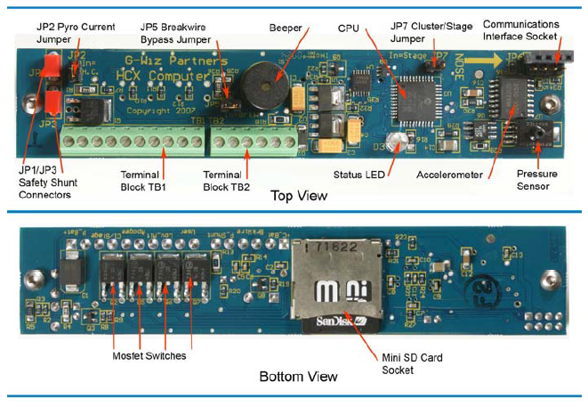

Below, each component of the HCX is listed and a brief description is given.

* **JP2 Jumper** – when jumper inserted: limits pyro outputs to 8 amps. When jumper absent: limits pyro output to 1 amp.
* **JP1/JP3 Jumper –** the safety shunt, when inserted: pyro outputs disabled. When absent: pyro outputs enabled. More on this later.
* **Terminal Block TB1 –** houses pyro port connections.
* **Terminal Block TB2 –** houses power connections.
* **JP5 Jumper –** when jumper inserted: breakwire launch detection enabled. When absent: breakwire launch detection disabled.
* **Beeper –** produces audible (loud) beeps. Used to communicate information during pre-flight and post-flight checks.
* **CPU** – the main processor of the HCX.
* **Status LED –** gives visual status indication. Used to communicate information during pre-flight and post-flight checks.
* **JP7 Jumper –** when inserted: pyro 1 fires at programmed event. When absent: pyro 1 fires when launch detected (approximately ½ second into flight).
* **Communication Interface Socket –** used to manually communicate data with the HCX. Will not be used in this application.
* **Accelerometer –** uses inertial techniques to calculate speed and altitude.
* **Pressure Sensor –** uses barometric techniques to calculate speed and altitude.
* **Mini SD Card Socket –** accepts a mini SD memory card. Data automatically recorded here during any operation.

**Terminal Blocks**

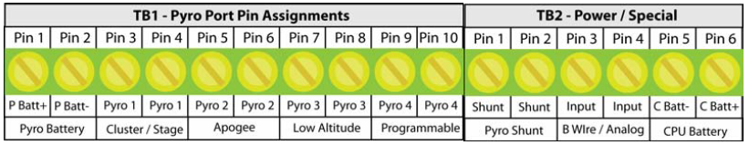

Beginning with terminal block 2 (TB2):

* **Pins 1 & 2 –** These two pins connect to both parts of the safety shunt assembly (JP1 and JP3).
* **Pins 3 & 4 –** Battery connections for the pyro outputs.
* **Pins 5 & 6 –** Battery connections for the CPU.

Terminal block 1 (TB1):

* **Pins 1 & 2 –** Battery connections for the pyro outputs.
* **Pins 3 & 4 –** Output connections for pyro output 1.
* **Pins 5 & 6 –** Output connections for pyro output 2.
* **Pins 7 & 8 –** Output connections for pyro output 3.
* **Pins 8 & 10 –** Output connections for pyro output 4.

**Pre-Flight Set-Up**

In this section, the processes for setting up the HCX for flight are given. It will include two sections. The first covering use of the Flight View software, the second goes over how to physically set the HCX up for use.

**Programming with Flight View**

Open Flight View.

The front page of the Flight View program looks like this.

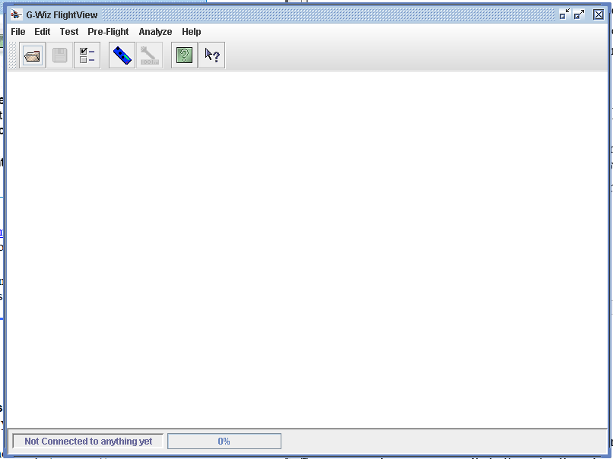

From here, to connect the HCX, go to file 🡪 Connect or press the button with the blue icon shaped like the HCX.

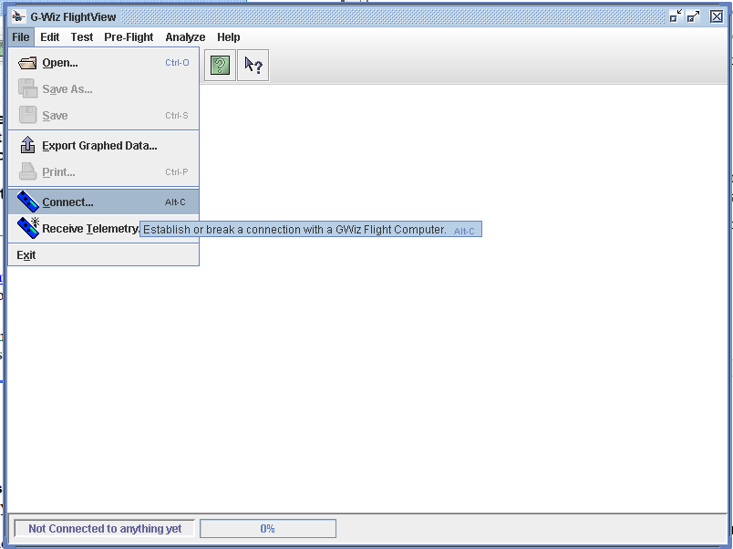

Now that the HCX is connected, open the “Pre-Flight” tab and select “Configure Computer…”

**IMPORTANT:** After changing the HCX’s settings using Flight View, the HCX must be turned off and rebooted before the settings will take effect.

**SRT**-**2** **Settings**

Settings to be used for SRT-2 launch:

Data File:

File Date: (today’s date)

File Size (max): (leave at default)

File Name Prefix: SRT2

Miscellaneous:

Metric Altitude Readout/Setting: unchecked

Max Airspeed (and Altitude) at Landing: unchecked

Sample Rate: 500 samples per second

Pyro 1:

If JP7 IN, Fire After: third burnout

Fire After Delay Of: 0.0 seconds

Pyro 2:

Inertial Apogee: checked

Barometric Apogee: unchecked

After: 0.0 seconds

Pyro 3:

Fire Below: (checked) 1100 feet/meters

Fire at Inertial Apogee: unchecked

After: 0.0 seconds

Pyro 4: Not Used

**NOTE:** when finished, press “Upload & Exit” button, then reboot HCX. New settings will not take effect unless the HCX has been rebooted.

**Formatting Memory Card**

The Mini-SD memory card used in the HCX must be formatted to FAT formatting. The included memory card should already be formatted correctly, however, if for any reason a new memory card is used, it must be reformatted to FAT.

To format a memory card, connect it into a computer, and when prompted, select the “Open folder to view files” option. In the panel on the left showing the file system, underneath “Computer,” right click the SD card and select “Format.” Select the FAT format. If the FAT format is not available, select the FAT32 format. If neither are available, obtain a new Mini-SD card. Leave all other options at their default settings, and select “start” at the bottom of the window.

**Status Codes**

When connected to a battery, the HCX runs a self-diagnostic and reports any errors using the on board LED and beeper. The normal, non-fatal, and fatal error codes are as follows.

Normal:

1. LED turns on then off.
2. LED turns on
   1. One low-pitch beep if JP7 absent
   2. Two low-pitch beeps if JP7 inserted
3. One half-second pause
4. Beeps status of each pyro port, beginning with pyro 1.
   1. One short beep: continuity
   2. Two short beeps: no continuity
5. Repeat from step two.

Non-fatal:

Low battery: same as normal sequence, with short warble in between steps 3 & 4

Mini-SD card absent: same as normal sequence, with long high-pitch and long low-pitch beeps in between step 1

**NOTE:** if the Mini-SD card is not inserted, the HCX will function as programmed, however it will not record any data.

Fatal:

Breakwire not connected: short warble repeated every one second.

Power-on self-test failure:

1. Long warble
2. Wait one half-second, up to seven beeps.

**NOTE:** if either fatal errors are reported, abort flight immediately and see HCX manual page 16 for further instruction.

**Pre-Flight checklist**

**NOTE:** This section assumes that the HCX has been programmed and is ready for flight. If the HCX has not been programmed and is not ready for flight, please complete the preceding section “Pre-Flight Set-Up.”

Continue if the HCX is programmed and ready for flight.

1. Install safety shunt (JP1/3)
2. Remove JP5 jumper.
   1. Ensure there is no short across TB2-5 and TB2-6.
3. Install JP2 jumper.
4. Install JP7 jumper.
5. Ensure Mini-SD memory card is properly inserted
6. Connect batteries
   1. Connect the positive end of battery 1 to TB1-1.
   2. Connect the negative end of battery 1 to TB1-2.
   3. Connect the positive end of battery 2 to TB2-6.
   4. Connect the negative end of battery 2 to TB2-5.
7. Ensure HCX gives no error codes.
   1. LED turns on and then off
   2. LED on, two low-pitch beeps
   3. LED off, one half-second pause
   4. Four short beeps.
8. Connect Drogue E-matches
   1. Connect positive end of drogue match to TB1-5.
   2. Connect negative end of drogue match to TB1-6.
9. Connect Main E-matches
   1. Connect positive end of main match to TB1-7.
   2. Connect negative end of main match to TB1-8.
10. Connect back up pyro?
11. Confirm that safety shunt JP1/3 is installed correctly.
12. Install HCX flight computer into rocket.
13. Close flight computer chamber.
14. Maneuver rocket into launch position.
15. Remove safety shunt.

**NOTE:** once safety shunt JP1/3 has been removed, the flight computer is “armed.” The safety shunt must be re-inserted if flight aborted on launch pad.

**Post-Flight Procedure**

How to turn off and then collect data

How to read data in field (beeps and computer)

1. Open chamber
2. Confirm HCX status (beeps)
3. Power down HCX

**Recovery**

After landing, the HCX will begin beeping. These beeps contain information regarding the maximum altitude obtained by the rocket. The beeps will continue until the HCX loses power, either intentionally or unintentionally. The HCX will beep a certain number of times in one *beep sequence* and a *beep sequence* represents each digit of the altitude. For example, a three-digit altitude will consist of one beep sequence.

The number zero is represented by one long beep, one is represented by one short beep, two by two sort beeps, and so on. After the altitude has been read, the HCX pauses for one full second, and then repeat the operation. A few examples are listed below.

“---“ = one long beep “*” = one short beep “_“ = one short pause

|  |  |
| --- | --- |
| Altitude | Beeps |
| 123 feet | *_**_*** |
| 5,208 feet | *****_**_---_******** |
| 10,321 feet | *_---_***_**_* |

**Data Collection**

After a flight data can be collected one of two ways. The first way, and only one covered in this manual, is to remove the Mini-SD card and connect it to a computer.

**NOTE:** do not remove the Mini-SD card from the HCX while the HCX is powered on. The HCX MUST be powered off before removing the Mini-SD card.

Once the Mini-SD card has been connected, open the Flight View program, go to “File” and then select “Open.” From here, find the Mini-SD card in the file system and select the desired flight data (.GWZ) file. Press the “open” button.

**NOTE:** every time the HCX is powered on, it creates a header file in anticipation of a flight. This may lead to having one more file present than flights conducted. This may produce an error when opening the file. Be wary of this when opening flight data files.